**Tutorial 34: Vue Router**

So far we have only been working with one page. Inside that page we have used multiple components that are all nested inside the App root component.

Remember Vue allows us to build a single page application, that sends a request to the server when the URL is entered and returns only one HTML file.

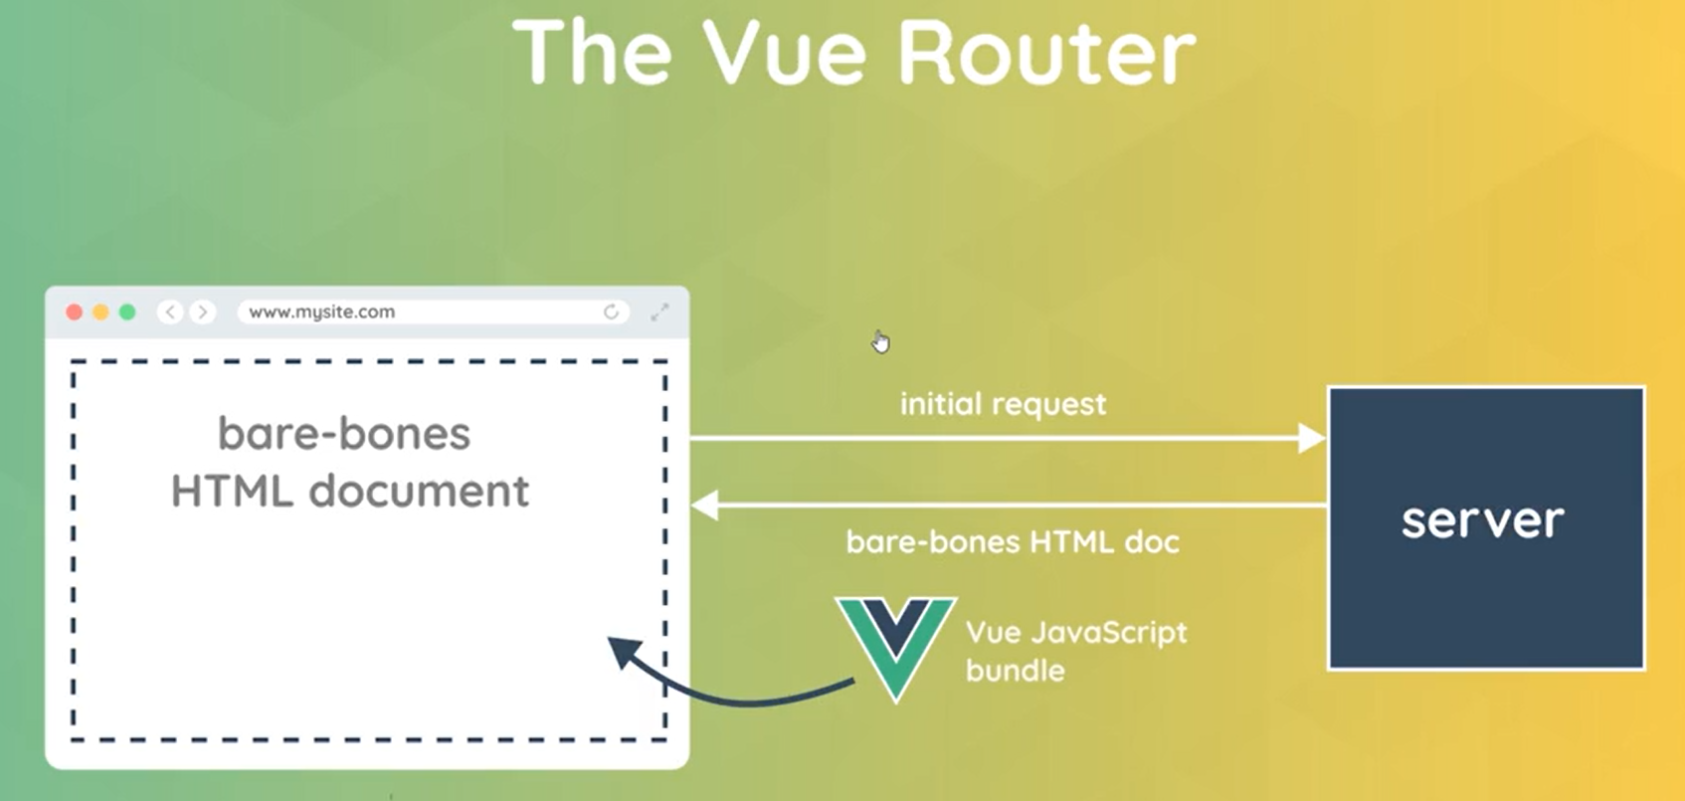

All of the Vue components are rendered on that single HTML file page starting with the root component that is injected into the HTML page.

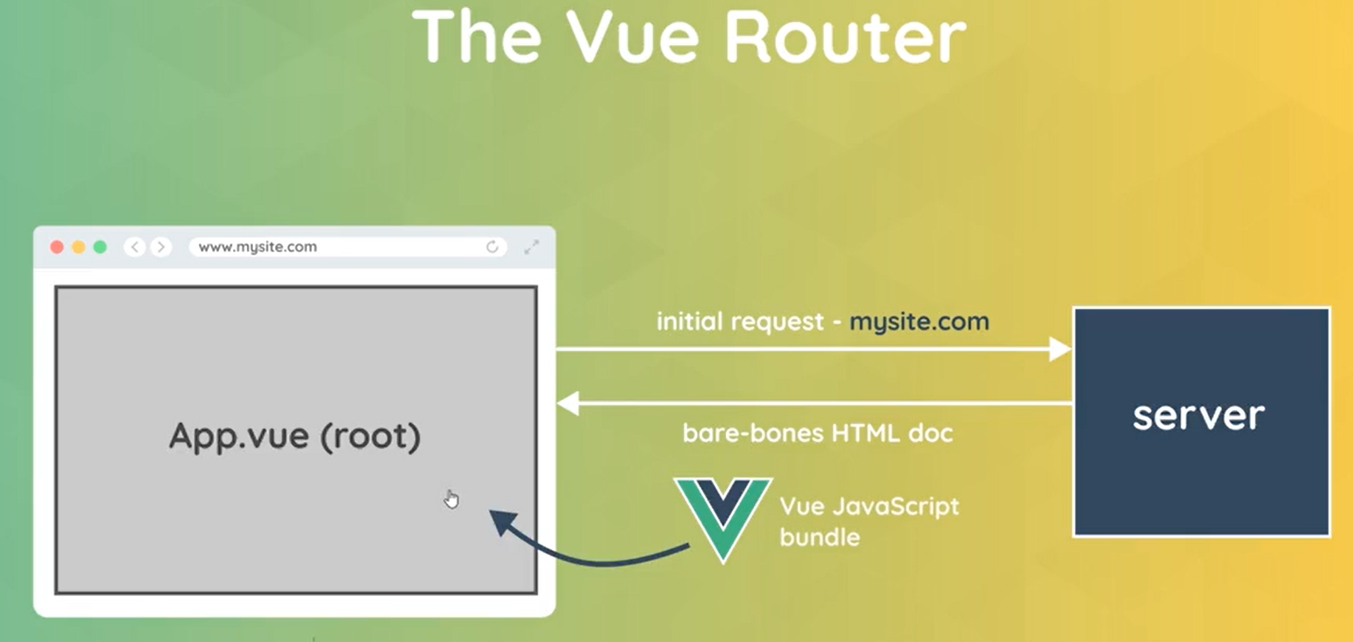

Vue router looks at the route we are currently on in the browser and it decides what components to nest inside the App component depending on that route.

**Example:**

This represents the Home.vue.

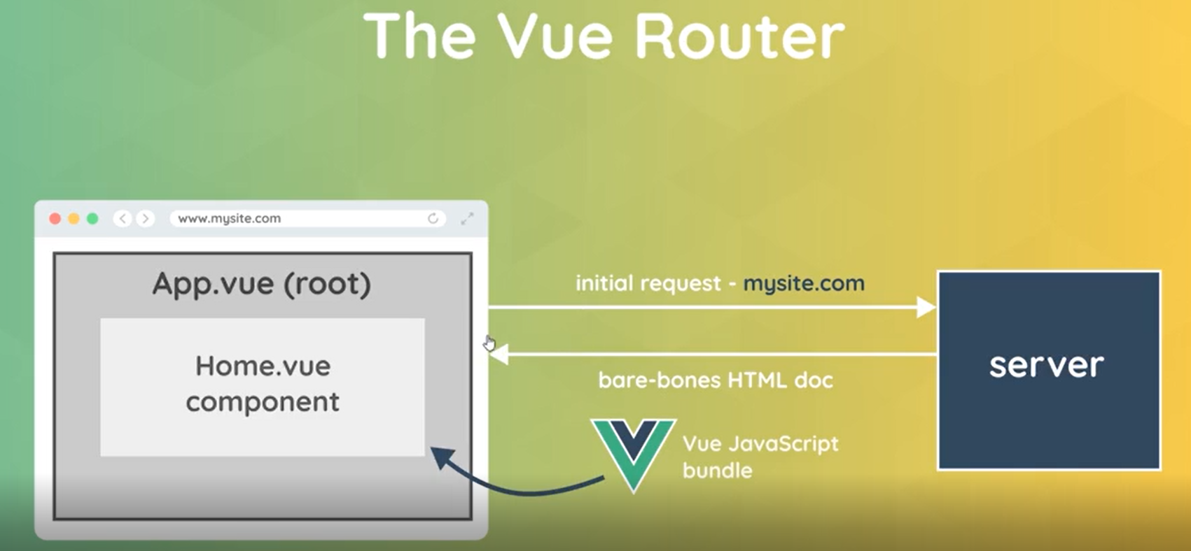

If we the url had /contact then this represents the Contact.vue.

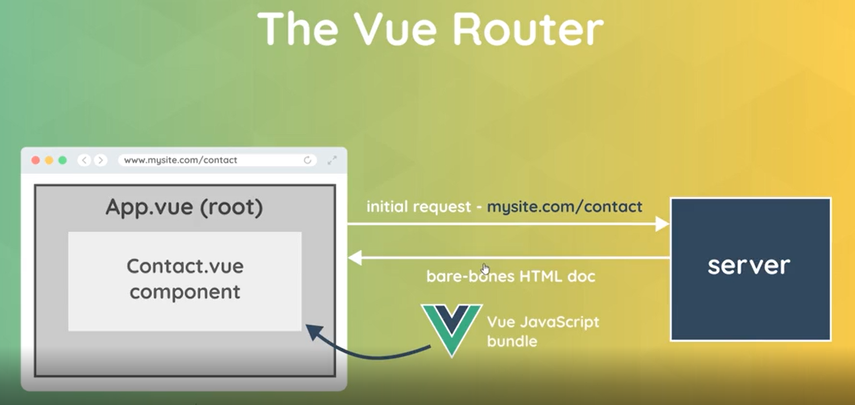

When the URL changes to the next route, it would unmount the previous component and nest the new component like an about component.

